**UNIVERSIDAD AUTÓNOMA “TOMÁS FRÍAS”**

**FACULTAD DE CIENCIAS PURAS**

**CARRERA DE INGENIERÍA INFORMÁTICA**



Práctica No. 1

|  |  |
| --- | --- |
| **Nombre:** | Hector Josue Condori Chambi |
| **CI:** | 8631891 Po |
| **Materia:** | Sensorización y Automatización Internet de la  Cosas (IoT) (INF640) |
| **Docente:** | Orlando Choque Ayma |
| **Fecha:** | 3 de octubre del 2023 |

**Potosí – Bolivia**

MQ2 Gas Sensor

[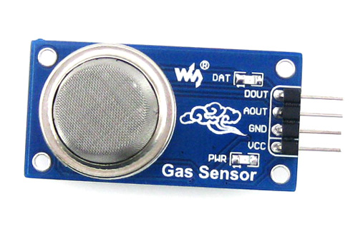](https://components101.com/sites/default/files/components/MQ2-gas-sensor.jpg)[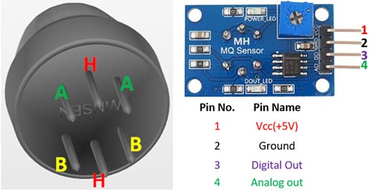](https://components101.com/sites/default/files/component_pin/MQ2-Gas-sensor-Pinout.jpg)

|  |  |  |
| --- | --- | --- |
| **Pin No:** | **Pin Name:** | **Description** |
| **FOR MODULE** | | |
| 1 | Vcc | This pin powers the module, typically the operating voltage is +5V |
| 2 | Ground | Used to connect the module to system ground |
| 3 | Digital Out | You can also use this sensor to get digital output from this pin, by setting a threshold value using the potentiometer |
| 4 | Analog Out | This pin outputs 0-5V analog voltage based on the intensity of the gas |

**Features**

* Operating Voltage is +5V
* Can be used to Measure or detect LPG, Alcohol, Propane, Hydrogen, CO and even methane
* Analog output voltage: 0V to 5V
* Digital Output Voltage: 0V or 5V (TTL Logic)
* Preheat duration 20 seconds
* Can be used as a Digital or analog sensor
* The Sensitivity of Digital pin can be varied using the potentiometer

LM393 Sound Detection Sensor Module

[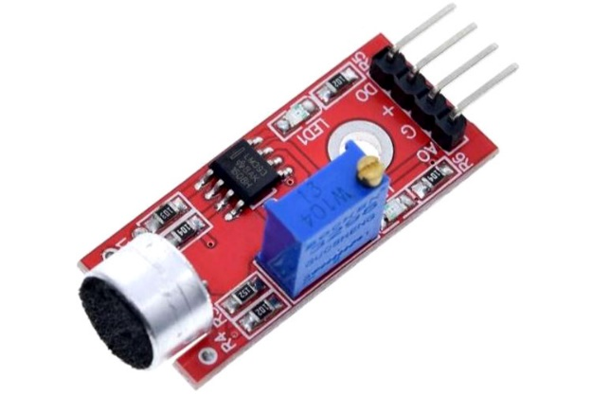](https://components101.com/sites/default/files/components/Sound-Detection-Sensor-Module.jpg)[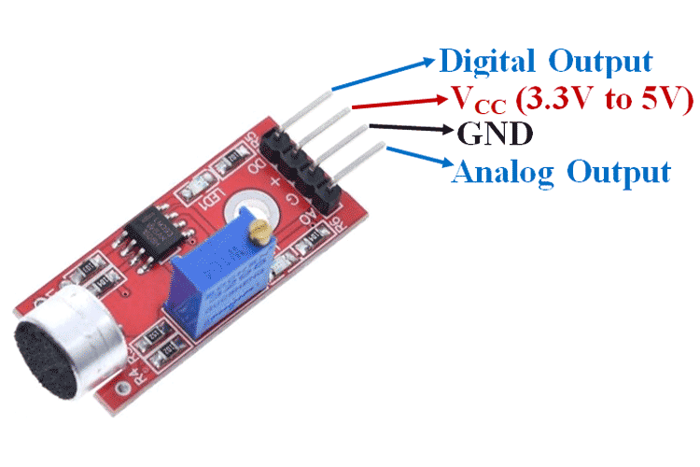](https://components101.com/sites/default/files/component_pin/Sound-Detection-Sensor-Module-Pinout.png)

**Sound Detection Sensor Module**

**Sound detection sensor module** detects the intensity of sound where sound is detected via a microphone and fed into an [**LM393 op-amp**](https://components101.com/ics/lm393-low-offset-voltage-dual-comparators). It comprises an onboard potentiometer to adjust the setpoint for sound level.

**Sound Detection Sensor Module Pin Configuration**

|  |  |
| --- | --- |
| **Pin Name** | **Description** |
| VCC | The Vcc pin powers the module, typically with +5V |
| GND | Power Supply Ground |
| DO | Digital Output Pin. Directly connected to digital pin of Microcontroller |
| AO | Analog Output Pin. Directly connected to an analog pin of Microcontroller |

**Sound Detection Sensor Module Features & Specifications**

* Operating Voltage: 3.3V to 5V DC
* LM393 comparator with threshold preset
* PCB Size: 3.4cm * 1.6cm
* Induction distance: 0.5 Meter
* Operating current:  4~5 mA
* Microphone Sensitivity (1kHz): 52 to 48 dB
* Easy to use with Microcontrollers or even with normal Digital/Analog IC
* Small, cheap and easily available

HC-SR04 Ultrasonic Sensor

[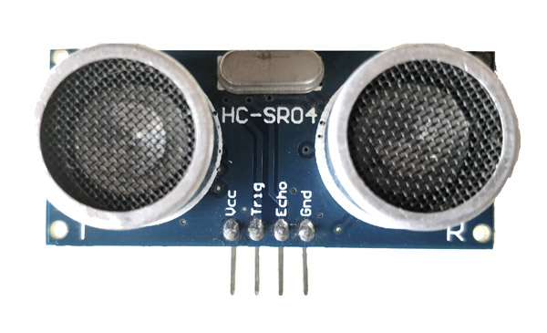](https://components101.com/sites/default/files/components/Ultrasonic-Sensor.jpg)[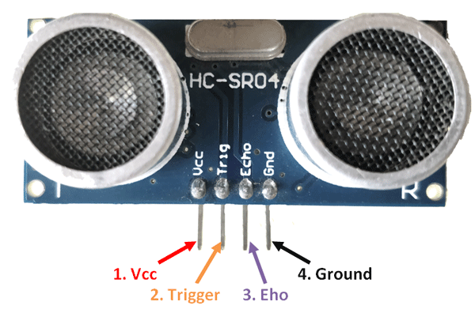](https://components101.com/sites/default/files/component_pin/Ultrasonic-sensor-pinout.png)

**Ultrasonic Sensor Pinout Configuration**

|  |  |  |
| --- | --- | --- |
| **Pin Number** | **Pin Name** | **Description** |
| 1 | Vcc | The Vcc pin powers the sensor, typically with +5V |
| 2 | Trigger | Trigger pin is an Input pin. This pin has to be kept high for 10us to initialize measurement by sending US wave. |
| 3 | Echo | Echo pin is an Output pin. This pin goes high for a period of time which will be equal to the time taken for the US wave to return back to the sensor. |
| 4 | Ground | This pin is connected to the Ground of the system. |

**HC-SR04 Sensor Features**

* Operating voltage: +5V
* Theoretical  Measuring Distance: 2cm to 450cm
* Practical Measuring Distance: 2cm to 80cm
* Accuracy: 3mm
* Measuring angle covered: <15°
* Operating Current: <15mA
* Operating Frequency: 40Hz

DHT11–Temperature and Humidity Sensor  
[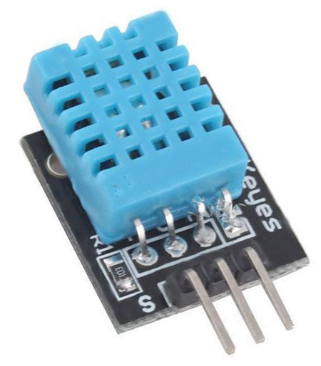](https://components101.com/sites/default/files/components/DHT11-Sensor.jpg)[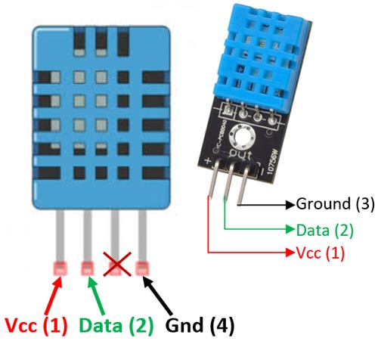](https://components101.com/sites/default/files/component_pin/DHT11%E2%80%93Temperature-Sensor-Pinout.jpg)

 The **DHT11**is a commonly used **Temperature and humidity sensor that** comes with a dedicated NTC to measure temperature and an 8-bit microcontroller to output the values of temperature and humidity as serial data.

**DHT11 Pinout Configuration**

|  |  |  |
| --- | --- | --- |
| **No:** | **Pin Name** | **Description** |
| 1 | Vcc | Power supply 3.5V to 5.5V |
| 2 | Data | Outputs both Temperature and Humidity through serial Data |
| 3 | NC | No Connection and hence not used |
| 4 | Ground | Connected to the ground of the circuit |
| **For DHT11 Sensor module** | | |
| 1 | Vcc | Power supply 3.5V to 5.5V |
| 2 | Data | Outputs both Temperature and Humidity through serial Data |
| 3 | Ground | Connected to the ground of the circuit |

**DHT11 Specifications**

* Operating Voltage: 3.5V to 5.5V
* Operating current: 0.3mA (measuring) 60uA (standby)
* Output: Serial data
* Temperature Range: 0°C to 50°C
* Humidity Range: 20% to 90%
* Resolution: Temperature and Humidity both are 16-bit
* Accuracy: ±1°C and ±1%

HC-SR501 PIR Sensor

[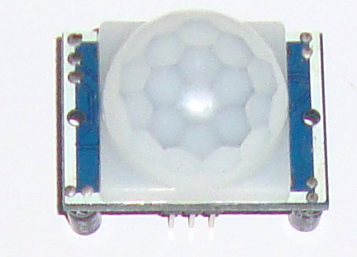](https://components101.com/sites/default/files/components/PIR-Sensor.jpg)[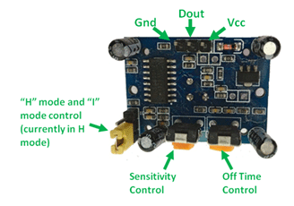](https://components101.com/sites/default/files/component_pin/PIR-Sensor-Pinout.png)

The PIR sensor stands for Passive Infrared sensor. It is a low cost sensor which can detect the presence of Human beings or animals. This **HC-SR501 PIR sensor module** has three output pins Vcc, Output and Ground as shown in the pin diagram above. Since the output pin is 3.3V TTL logic it can be used with any platforms like Arduino, Raspberry, [PIC](https://components101.com/pic16f877a-pin-diagram-description-features-datasheet), ARM, 8051 etc..

**PIR Sensor Module Pinout Configuration**

|  |  |  |
| --- | --- | --- |
| **Pin Number** | **Pin Name** | **Description** |
| 1 | Vcc | Input voltage is +5V for typical applications. Can range from 4.5V- 12V |
| 2 | High/Low Ouput (Dout) | Digital pulse high (3.3V) when triggered (motion detected) digital low(0V) when idle(no motion detected |
| 3 | Ground | Connected to ground of circuit |

**Note: *Read further to know about the details of other pins and PIR sensor datasheet.***

**PIR Sensor Features**

* Wide range on input voltage varying from 4.V to 12V (+5V recommended)
* Output voltage is High/Low (3.3V TTL)
* Can distinguish between object movement and human movement
* Has to operating modes - Repeatable(H) and Non- Repeatable(H)
* Cover distance of about 120° and 7 meters
* Low power consumption of 65mA
* Operating temperature from -20° to +80° Celsius

SW-420 Vibration Sensor Module

[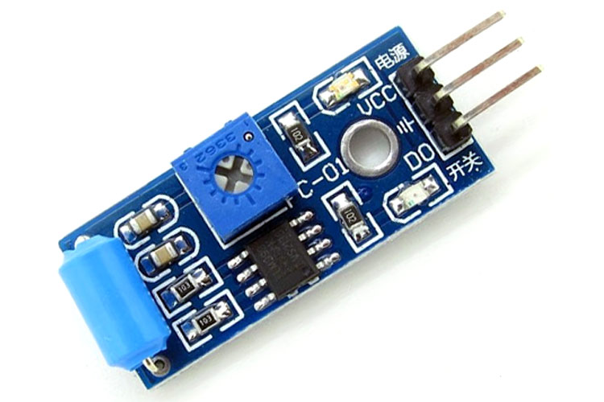](https://components101.com/sites/default/files/components/SW420-Vibration-Sensor-Module.jpg)[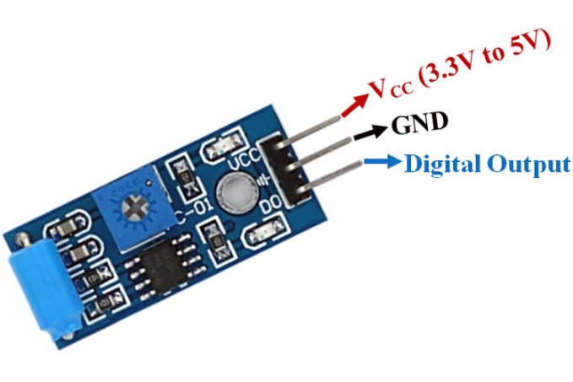](https://components101.com/sites/default/files/component_pin/Vibration-Sensor-Pinout.jpg)

The vibration sensor module based on the **vibration sensor SW-420** and Comparator LM393 is used to detect vibrations. The threshold can adjust using an on-board potentiometer. During no vibration, the sensor provides Logic Low and when the vibration is detected, the sensor provides Logic High.

**Pin Configuration of Vibration Sensor Module**

|  |  |
| --- | --- |
| **Pin Name** | **Description** |
| VCC | The Vcc pin powers the module, typically with +5V |
| GND | Power Supply Ground |
| DO | Digital Out Pin for Digital Output. |

**Vibration Sensor Module Features & Specifications**

* Operating Voltage: 3.3V to 5V DC
* Operating Current: 15mA
* Using SW-420 normally closed type vibration sensor
* LEDs indicating output and power
* LM393 based design
* Easy to use with Microcontrollers or even with normal Digital/Analog IC
* With bolt holes for easy installation
* Small, cheap and easily available